Question Bank-Unit 4&6 (MATH 3510)
(Numerical solution of ODE and PDE)

S. No. | Questions | CO | Bloom’s Taxonomy Level | Difficulty Level | Area | Topic
1 | State Taylor series method in solving IVP. | CO4 | K1 | L | Numerical Solution of ODE | Taylor’s series Method
2 | State a basic difference between Euler and Modified Euler methods. | CO4 | K1 | L | Numerical Solution of ODE | Euler’s Method
3 | Write down the Runge Kutta fourth order formula. | CO4 | K1 | L | Numerical Solution of ODE | R-K Method
4
5 | Define initial value problems (IVP) and boundary value problems (BVP). | CO4 | K1 | L | Numerical Solution of ODE | Basics of ODE
6
7 | Write down Euler’s formula for solving ODE. | CO4 | K2 | M | Numerical Solution of ODE | Euler’s Method
8
9 | What are limitations of Taylor’s series method. | CO4 | K2 | L | Numerical Solution of ODE | Taylor’s series Method
10 | Write down finite difference scheme for the differential equation- y’’+2y=0. | CO4 | K1 | L | Numerical Solution of ODE
11 | Classify the following PDE- | CO6 | K2 | M | Numerical Solution of PDE | Classification of PDE
12 | Classify the given partial differential equation-, | CO6 | K2 | M | Numerical Solution of PDE | Classification of PDE
13 | Classify the given partial Differential equation- | CO6 | K1 | L | Numerical Solution of PDE | Classification of PDE
14 | Explain diagonal five-point formula by Liebman’s method. | CO6 | K2 | M | Numerical Solution of PDE | Elliptic Equations- Solution of Laplace Equation
15 | Explain standard five point formula by Liebman’s method. | CO6 | K1 | L | Numerical Solution of PDE | Elliptic Equations- Solution of Laplace Equation
16 | Write down explicit formula in solving parabolic equations. | CO6 | K2 | M | Numerical Solution of PDE | Parabolic Equations- Bender Schmidt
17 | Write down Von- Neumann’s stability condition. | CO6 | K1 | M | Numerical Solution of PDE | Parabolic Equations- Bender Schmidt
18 | Write down implicit formula in solving parabolic equations. | CO6 | K2 | M | Numerical Solution of PDE | Parabolic Equations- Crank- Nicolson
19 | Write down the expression for one dimensional wave equation. | CO6 | K2 | L | Numerical Solution of PDE | Hyperbolic  Equations
20 | Write down the expression for Laplace equation. | CO6 | K2 | M | Numerical Solution of PDE | Laplace Equations
21 | Using Taylor’s series method, find the value of y at x=0.1 and 0.2, where 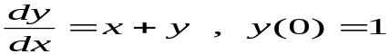 | CO4 | K2 | M | Numerical Solution of ODE | Taylor’s Series
22 | Using Euler’s method, find an approximate value of y corresponding to x=2, given that and | CO4 | K2 | M | Numerical Solution of ODE | Euler’s Method
23 | Using Runge’s method to find the value of y at x= 0.2, where 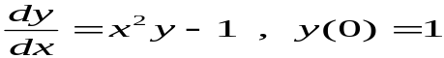 | CO4 | K4 | M | Numerical Solution of ODE | Runge Kutta Method
24 | Using Ranga kutta’s fourt order method, find the value of y at x= 0.2, where | CO4 | K2 | M | Numerical Solution of ODE | Runge Kutta Method
25 | Using Ranga kutta’s fourt order method, find the value of y at x=0.4 and 0.2, where 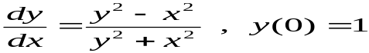 | CO4 | K4 | L | Numerical Solution of ODE | Runge Kutta Method
26 | Using Taylor’s series method, find the value of y at x=0.1 and 0.2, where | CO4 | K2 | M | Numerical Solution of ODE | Taylor’s Series
27 | Using Euler’s method, find an approximate value of y corresponding to x=1.6, given that and | CO4 | K3 | H | Numerical Solution of ODE | Euler’s method
28 | Solve the equation subject to the conditions u , 0< x < 1, ; Find u for x=0.6 at t =.04. | CO6 | K3 | M | Numerical Solution of PDE | Bender Schmidt
29 | Solve the equation 2 subject to the conditions , 0< x < 5, taking h=1 Find the values of u upto t=5. | CO6 | K4 | M | Numerical Solution of PDE | Bender Schmidt
30 | Solve the equation , subject to the conditions u(x,0)=0, u(0,t)=0 and u(1,t)=t, for two time steps. | CO6 | K3 | M | Numerical Solution of PDE | Crank Nicolson Method
31 | Solve BVP defined by u_{tt}=4u_{xx} subject to the conditions- u(0,t)=0=u(4,t), u_{t}(x,0)=0, u(x,0)=4x-x². | CO6 | K4 | H | Numerical Solution of PDE | Wave Equation
32 | Write method of solving Laplace equation by Liebman’s method. [ only for 3x3 table] | CO6 | K2 | M | Numerical Solution of PDE | Laplace Equation
33 | Define Runge Kutta 4th order formula for solving ordinary differential equations. | CO6 | K1 | M | Numerical Solution of ODE | R-K Method
34 | Using Euler’s modified method, find the value of y at x=0.3 where | CO6 | K3 | M | Numerical Solution of ODE | Euler’s Modified method
35 | Given that, , find y at x=0.1, 0.2, 0.3 by Taylor’s series method and compute by Milne’s method. | CO4 | K3 | M | Numerical Solution of ODE | Taylor’s Series/ Milne’s Method
36 | Using Runge’s method, find the value of y at x=0.2 where | CO4 | K4 | H | Numerical Solution of ODE | Runge Kutta Method
37 | Apply Euler’s modified method to solve subject to and, hence find an approximate value of y when x=1. Take h=0.2 | CO4 | K3 | H | Numerical Solution of ODE | Euler’s modified method
38 | Using Euler’s modified method, find the value of y at x=0.2 where 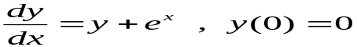 | CO4 | K4 | H | Numerical Solution of ODE | Milne’s method
39 | Using Euler’s modified method, find the value of y at x=1.2 where | CO4 | K4 | L | Numerical Solution of ODE | Euler’s modified method
40 | Using Taylor’s series method, find the value of y at x=0.1, 0.2 and 0.3, where 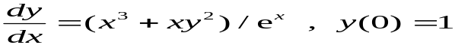 | CO4 | K4 | M | Numerical Solution of ODE | Taylor’s Series
41 |  | CO4 | K3 | M | Numerical Solution of ODE | Finite difference Method
42 | Using Euler’s method, find the value of y at x=1 where | CO4 | K4 | H | Numerical Solution of ODE | Eulers Method
43 | Solve 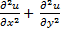= 0 within the square given below. Perform three iterations.  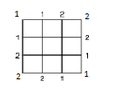 | CO6 | K4 | H | Numerical Solution of PDE | Laplace equation
44 | Solve 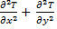= 0 in the domain of the figure given below by Liebman’s method,  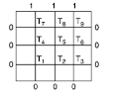 | CO6 | K4 | H | Numerical Solution of PDE | Laplace equation
45 | Solve the equation subject to the conditions u , 0< x < 5, taking h=1, k= 1/2. | CO6 | K3 | M | Numerical Solution of PDE | Bender Schmidt Method
46 | Solve the equation 16 subject to the conditions 0< x < 1, t > 0 ; u(x,0)=0, 0, u(1,t)=100t. Compute u for one step in t direction taking h=1/4. | CO6 | K3 | M | Numerical Solution of PDE | Crank Nicolson’s Method
47 | Solve = 0 by Liebman’s iteration process for the domain of the figure, given below:  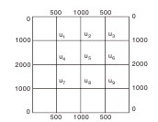 | CO6 | K3 | L | Numerical Solution of PDE | Laplace equation
48 | Evaluate the pivotal values of the equation , taking h=1 up to t=1.25. The boundary conditions are and . | CO6 | K3 | H | Numerical Solution of PDE | Hyperbolic
49 | Solve the equation subject to the conditions u , 0< x < 1, ; Find u for x=0.6 at t =.04. | CO6 | K3 | M | Numerical Solution of PDE | Crank Nicolson’s Method
50 | Solve = 0 within the square given below. Perform three iterations.  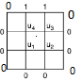 | CO6 | K3 | M | Numerical Solution of PDE | Laplace equation
51. | Write the standard five point formula to solve the Laplace equation 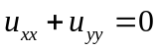 | CO6 | K1 | L
 | For what value of c the wave equation 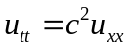 has the accurate and stable solution | CO6 | K2 | M

